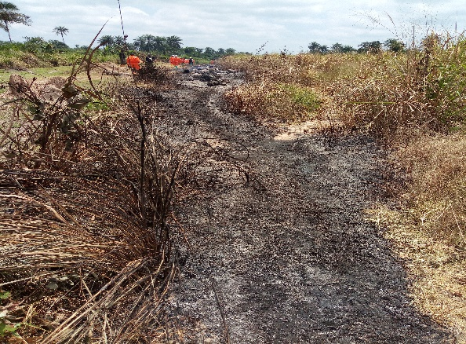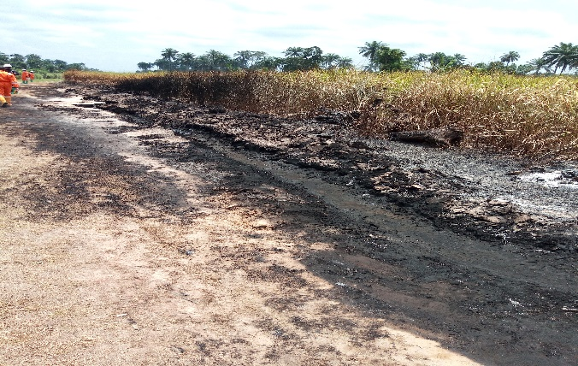
Fig.1: The burnt area (soil and vegetation) on Total E&P’s Right of Way
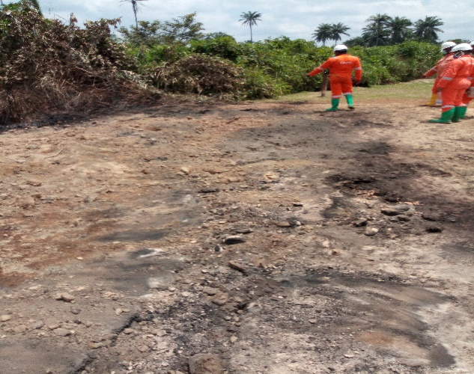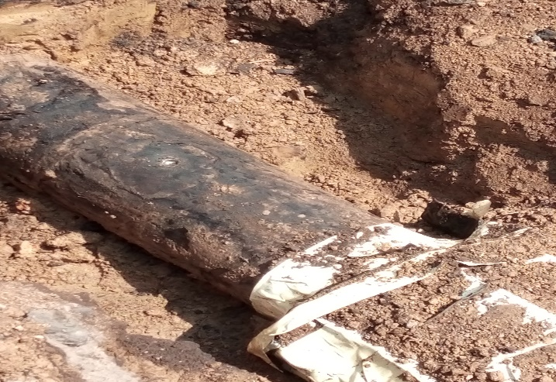
Fig.2: The Spill Area (spill point at 12 O’clock position indicated with an arrow on the second picture)
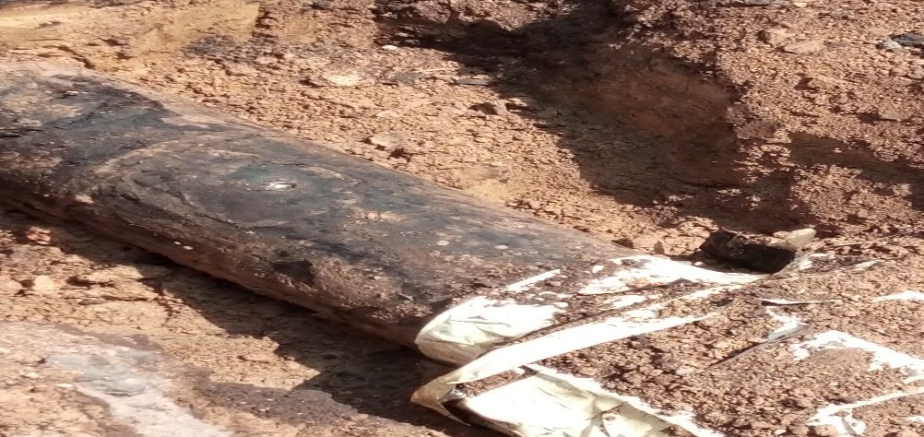
Fig.3: The spill point close to a previous clamped point (the arrow indicates the distance between both points which is 0.5m).
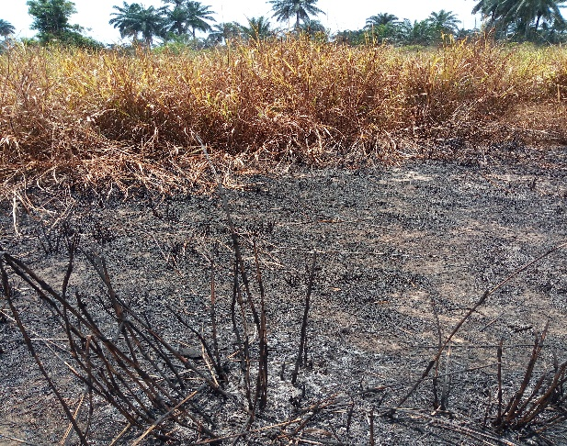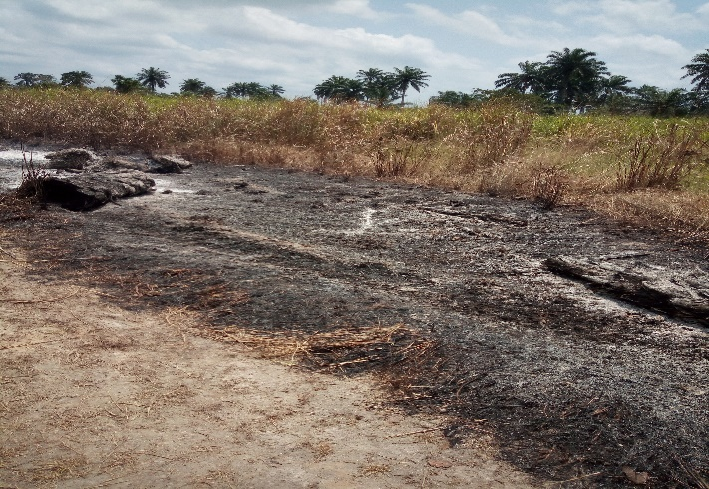
Fig.4: The Impacted area (both soil and vegetation were affected by the fire outbreak)

